Port of Fowey Racing

SAILING INSTRUCTIONS

Salcombe Yawls Fowey Open

Saturday 25th & Sunday 26th June 2015

ROYAL FOWEY YACHT CLUB FOWEY GALLANTS SAILING CLUB
Tel: 01726 833573 Tel: 01726 832335
The organising authority is the Port of Fowey Race Organising Committee (POFROC), an unaffiliated body owned and controlled by the Royal Fowey Yacht Club (RFYC) and Fowey Gallants Sailing Club (FGSC).
- Rules
  - Racing will be governed by the rules as defined in the Racing Rules of Sailing and the prescriptions of the RYA.
  - The Fowey Harbour Byelaws and Notices to Mariners published by the Fowey Harbour Commissioners (FHC) apply both within the harbour and the approaches to it. (The Byelaws are available from FHC or at http://www.foweyharbour.co.uk/assets/file/pdfs/Downloads/byelaws.pdf)
- Notices to Competitors
Notices to competitors will be posted on the official notice board located at the RFYC.
- Changes to Sailing Instructions
Any changes to the Sailing Instructions will be posted a minimum of one hour before the scheduled starting time of the race or races affected, except that any change to the schedule of races will be posted by 2000hrs on the day before it will take effect.
- Signals Made Ashore
Signals made ashore will be displayed from the flagstaff or race office at RFYC.
- Schedule of Races
  - The Schedule of Race Series, Start Times and Time Limits, is on page 3 of the Sailing Instructions.
  - The Race Committee may alter or reschedule the above programme for any reason, including preserving the Open status.
- Class Flags - Class flags are as listed in the Notice of Race.
- Racing Areas, Marks and Courses
  - The racing areas and marks will be as described in Appendices 1 and 2.
  - The course and number of laps to be sailed by each class will be signalled on boards displayed by the race office.
  - The class will be indicated by a white board with the class sign in black preceding the relevant course.
  - The course will be indicated by lettered boards, a green background for marks to be passed to starboard and a red background for marks to be passed to port.
  - The number of laps, if more than one, will be indicated by a white board with a black number.
- The Start
  - Races will be started using rule 26.
  - An attention signal (orange flag or amber light with one sound) will be displayed five minutes before the warning signal for the first start.
  - Races started on Line One will use the Starting Light System as described in Appendix 3.
  - Starting Line - a line extending from a transit formed by a white triangle with an orange border on the buildings behind the race office and the RFYC flagstaff limited by a line perpendicular to this start line that passes though mark B.
  - If flag O is displayed with two sound signals prior to the attention signal, competitors shall not enter the moorings on the Fowey side of the harbour until they have started.
- Shortening/Changing the Course
  - When races are shortened using rule 32, if possible boats are requested to note the competitors that finish directly before and after them in their class.
  - After the starting signal, the race officer may shorten (flag S displayed with two sounds) or abandon the race (flag N, N over H or N over A displayed with three sounds) for the following reasons,
    - an error in the starting procedure,
    - foul weather,
    - insufficient wind making it unlikely that any boat will finish within the time limit,
    - a mark is missing or out of position,
    - for any other reason which directly affects the safety or fairness of the race.
  - If the race officer shortens the course, the finishing line shall be,
    - at a rounding mark, between the mark and a staff on a safety boat displaying flag S;
    - at a line that the boats are required to cross at the end of each lap;
    - at a gate, between the gate marks.
The shortened course shall be signalled before the first boat crosses the finishing line.
  - If a committee boat displays flag C with a repetitive sound signal the course shall be changed and boats shall round the adjacent mark of the course and proceed directly to the designated finishing line. This is in addition to rules 32.2 and 33, and alters the meaning of Race Signal flag C.
- The Finish
Finishing line - a line extending from the RFYC flagstaff to the seaward side (south side) of mark B, with this mark as the
outer distance mark.
- Time Limits
  - Time limits will be as given in the Schedule of Race Series.
  - For all races if one (or more) boats finish within the time limit, the time limit will be extended by half an hour. Boats failing to finish within the time limit will be scored Did Not Finish (DNF). This changes rule 35.
- Protests and Requests for Redress
  - The Exoneration Penalty, Advisory Hearing and RYA Arbitration of the RYA Rules Disputes Procedures will be available. See the notice boards at RFYC or FGSC for details.
  - Protest forms are available at the race office. Protests and requests for redress shall be delivered there within the protest time limit.
  - The protest time limit is 60 minutes after the last boat has finished the last race of the day.
  - Notices will be posted within 24 hours of the protest time limit to inform competitors of hearings in which they are parties or named as witnesses. Hearings will be held at the time and place stated on the notice.
  - Notices of protests by the race or protest committee will be posted to inform boats under rule 61.1(b).
  - The penalty for breaking rule 55, Trash Disposal, will be at the discretion of the protest committee.
- Scoring
  - The number of races to count for the series will be two races if all four races are sailed there will be one discard.
  - All boats will race together but there will be 1st, 2nd & 3rd prizes for boats in each fleet, Modern and Classic.
  - The paragraphs above change the definition of racing rules A2 series scores in Appendix A Scoring.
- Handicaps
  - Handicap racing for the Open will be done using the Salcombe Yawls association handicaps.
  - Queries on handicaps should be submitted in writing to Salcombe Yawls association.
- Safety Regulations
  - Identification. Sail numbers are compulsory and shall be the same as on the entry form.
  - Personal flotation devices. Rule 40, personal flotation devices, shall apply to all competitors whilst racing without the display of flag Y. This requirement alters rule 40.
  - Alternative means of propulsion. All boats shall have an effective alternative means of propulsion for safety.
  - Retirements. A boat that retires from a race shall notify the race committee as soon as possible by one of the following means: visual, oral or radio message to a committee boat, safety boat or the race office; telephone call to the race office (01726 833573/832245)
    - Competitors having retired should endeavour not to pass through the finishing line.
    - Failure to notify retirement may result in disqualification from the open.
  - Committee boats, safety patrol boats and the race office all operate on VHF Channel M2.
- Risk Statement
Rule 4 states: “The responsibility for a boat’s decision to participate in a race or to continue racing is hers alone.” Sailing is by its nature an unpredictable sport and therefore inherently involves an element of risk. By taking part in the event, each competitor agrees and acknowledges that:
- They are aware of the inherent element of risk involved in the sport and accept responsibility for the exposure of themselves, their crew and their boat to such inherent risk whilst taking part in the event;
- They are responsible for the safety of themselves, their crew, their boat and property whether afloat or ashore;
- They accept responsibility for any injury, damage or loss caused by their own actions or omissions;
- Their boat is in good order, equipped to sail in the event and they are fit to participate;
- The provision of a race management team, safety patrol boats and other officials and volunteers by the event organiser does not relieve them of their own responsibilities;
- The provision of safety patrol boat cover is limited to such assistance, particularly in extreme weather conditions, as can be practically provided in the circumstances;
- Insurance
Each participating boat shall be insured with valid third-party liability insurance with a minimum cover of £2,000,000 per event or the equivalent.

Schedule Salcombe Yawls Fowey Open 2015
Please note - Briefing is @ 1000 at FGSC on Saturday 25th June 2015
Prize giving is @ 1500 at RFYC on Sunday 26th June 2015
The race officer may change the start times and schedule of races to ensure all races can be run (see notice board).
 | Saturday (25.06.15) |  | Sunday (26.06.15) |  | Tide times
 | start time | time limit | start time | time limit | Low Water | High Water
Race 1 | 1115 | 1300 |  |  | 15:48 (1.3m) | 0938 (4.9m)
Race 2 | 1440 | 1700
Race 3 |  |  | 0945 | 1130 | 16:31 (1.4m) | 1016 (4.9m)
Race 4 |  |  | 1200 | 1345

Appendix 1

Racing Area and Marks for In-Harbour courses

This chart indicates the areas in which the in-harbour marks will be laid.
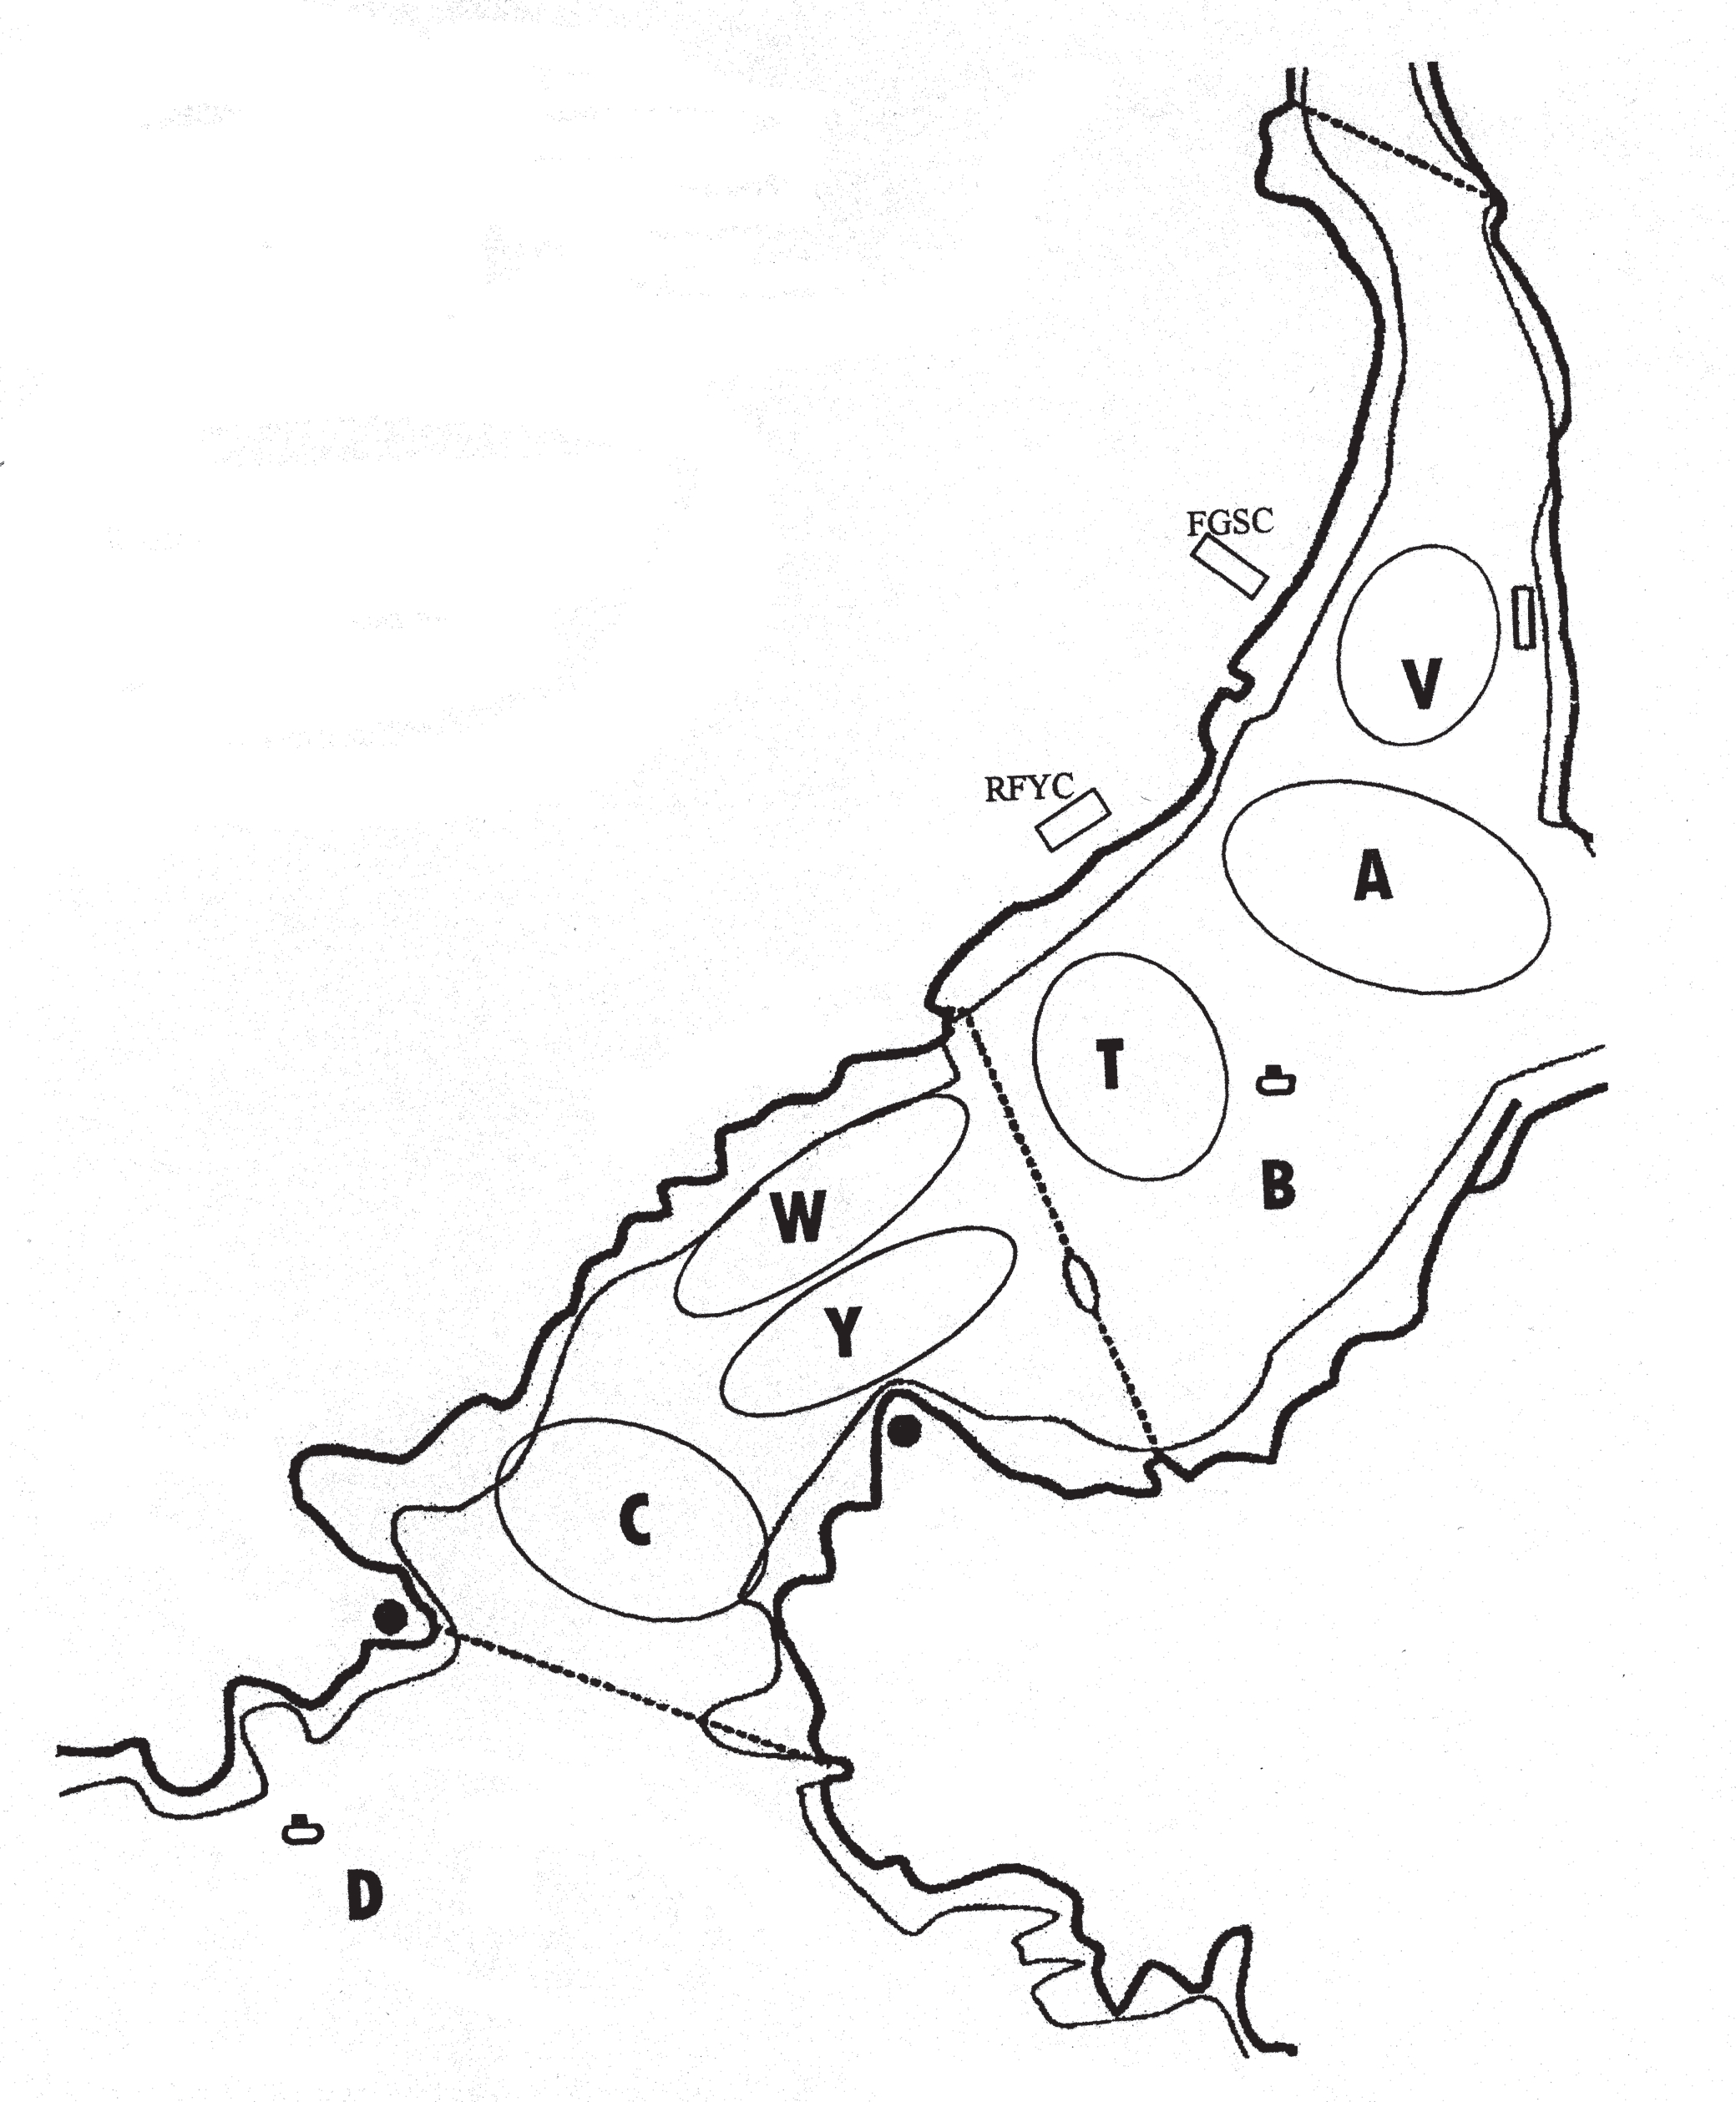
Description of Marks
Mark B – Silver Turning Buoy off RFYC.
Marks A, C, T, V, W & Y – "pipe" buoys with flag topmarks.
Outside harbour marks are as described in Appendix 2.

Navigation
Passage between Punches Cross and the eastern shore and Lamp Rock and the eastern shore is forbidden as is passage between Cannis Rock and the adjacent shore. Cannis Rock Buoy is to be passed on its correct navigational side unless designated as a mark of the course.

Appendix 2

Racing Area and Marks for Offshore Courses

This chart must not be used for navigation.
The position of marks is for identification only.

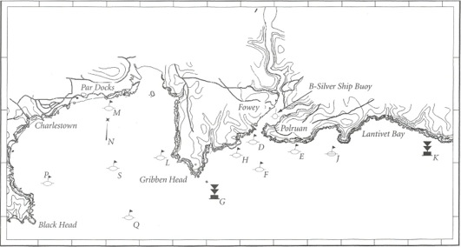

Description of Marks and Approximate Positions
D St. Austell Brewery “Tribute” 50º 19.504′ 4º 38.838′ Yellow Spherical buoy
E Sail Shape 50º 19.333' 4º 37.956' Yellow Spherical buoy
F Dinghy South 50º 19.0' 4º 38.5' Yellow inflatable
G Cannis Rock Buoy 50º 18.450' 4º 39.879' IALA South Cardinal buoy
H Four Turnings Garage 50º 19.233' 4º 39.325' Yellow Spherical buoy
J Kim Furniss 50º 19.1' 4º 36.4' Yellow Spherical buoy
K Udder Rock Buoy 50º 18.930' 4º 33.848' IALA South Cardinal buoy
L Kettle Kitchens 50º 19.122' 4º 41.462' Yellow Spherical buoy
M The Beach 50º 20.041' 4º 42.856' Yellow Spherical buoy
N Bay Buoy 50º 19.511' 4º 43.052' IALA Yellow Special buoy
P Bennett Jones Chartered Accountants 50º 18.0' 4º 43.800' Yellow Spherical buoy
Q Quay Bakery 50º 18.0' 4º 42.5' Yellow Spherical buoy
S Fowey Hall Hotel 50º 18.9' 4º 42.8' Yellow Spherical buoy

Mark B – Silver Turning Buoy off RFYC.

Navigation
The Cannis Rock and Udder Rock Buoys are to be passed on their correct navigational sides, unless designated as marks of the course. Passage between the Cannis Rock and the adjacent shore is forbidden.

POFROC and all competitors are appreciative of our sponsors without whom
use of our yellow racing marks would not be possible.

Appendix 3

- Starting Light System (SLS)
  - Races started on Line One will use the Starting Light System as described below. This changes rule 26.
  - If the Starting Light System is inoperative the flag signals of rule 26 will be used signalled by flag A displayed on the RFYC flagstaff.

- The Lights Described
  - Attention Signal - Three amber lights displayed just below the yardarm on the RFYC flagstaff. Each light covers a separate sector of the harbour, so from most positions only a single amber light may be visible. The attention signal with one sound will be made five minutes before the warning signal for the first class to start.
  - Warning Signals - The warning signals will be differently coloured class lights displayed along the top of the left hand window of the Race Office (as seen from the harbour). The order of lights from the upper left-hand corner will be:
Red - Salcombe Yawls
Yellow - Dinghy F and Fowey Rivers
White - Troys
Amber - Cruiser Class
Green - Dinghy K
The warning signal for each class (or classes) with one sound will be made five minutes before the starting signal.
  - Preparatory Signal - The preparatory signal will be a white light displayed in the lower right-hand corner of the window. The preparatory signal with one sound will be made four minutes before the starting signal.
  - One-Minute - The one-minute signal will be a white light displayed in the lower left-hand corner of the window. The one-minute signal with one sound will be made one minute before the starting signal.
  - Starting Signal - The class (classes), preparatory and one-minute lights will go out simultaneously with one sound.
  - When classes are being started at five-minute intervals the warning signal for each succeeding class will be made with the starting signal of the preceding class.

- Individual Recall
The individual recall signal will be the appropriate class (or classes) light(s) and one sound. The light(s) will stay on until all the boats that were over the line are completely on the pre-start side of the starting line, but not later than four minutes after the starting signal. This changes rule 29.1.

- General Recall
The general recall signal will be the appropriate class (or classes) light(s) flashing and two sounds. The warning signal for a new start for the recalled class will be made one minute after the flashing light(s) goes out with one sound, and the starts of any succeeding classes will follow the new start. This changes rule 29.2.

- Postponement (For any races not started)
The postponement signal will be the amber time signal lights flashing and two sounds. The end of the postponement will be signalled by the amber lights ceasing to flash and one sound. The warning signal will be made one minute after the end of the postponement unless at that time the race is postponed again or abandoned. This changes rule 27.3.

- Abandonment
Abandonment will be signalled by flag signals as described in rules 27.3 and 32.1 (or see 10.2 above).

