Port of Fowey Racing

Notice of Race

Salcombe Yawls Fowey Open Saturday 25th&Sunday 26thJune 2016
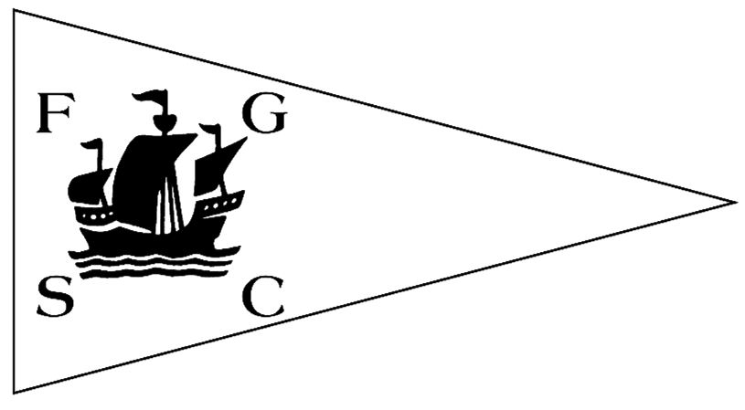

ROYAL FOWEY YACHT CLUB FOWEY GALLANTS SAILING CLUB
Tel: 01726 833573 Tel: 01726 832335
The organising authority is the Port of Fowey Race Organising Committee (POFROC), an unaffiliated body owned and controlled by the Royal Fowey Yacht Club (RFYC) and Fowey Gallants Sailing Club (FGSC).
- Rules
  - Racing will be governed by the rules as defined in the Racing Rules of Sailing and the prescriptions of the RYA.
  - Racing rules 26 starting races, 27 starting signals, 29 recall signals, 32 shortening course, 33 change of course, 35 time limits, 40 personal flotation devices, 77 sail identification and 80 advertising, are subject to change. The changes will appear in full in the Sailing Instructions. The Sailing Instructions may also change other racing rules.
  - The Fowey Harbour Byelaws and Notices to Mariners published by the Fowey Harbour Commissioners (FHC) apply both within the harbour and the approaches to it. (The Byelaws are available from FHC or at http://www.foweyharbour.co.uk/assets/file/pdfs/Downloads/byelaws.pdf)
- Eligibility and Entry
Racing is open to all Salcombe Yawls (with class flags):

  - Entry for the events shall be by completion of the Entry Form, and payment of the relevant fee as indicated on the Entry Form.
  - A share of the paid entry fee for each boat shall constitute membership of POFROC for the purposes of racing in the Port of Fowey.
- Schedule of Races
  - A series of four races will form the open event.
  - Details of race series start times and time limits are given in the Schedule of Race Series in the Sailing Instructions.
- Sailing Instructions
  - Sailing Instructions will be available online on the websites of both clubs and the Salcombe Yawl association by the end of April. No boat shall race until its entry has been accepted.
- Penalty System
The Exoneration Penalty, Advisory Hearing and RYA Arbitration of the RYA Rules Disputes Procedures will be available. See the official notice boards at RFYC and FGSC for details.
- Scoring
  - The number of races to count for the series will be two races if all four races are sailed there will be one discard.
  - The paragraphs above change the definition of racing rules A2 series scores in Appendix A Scoring.
- Prizes
Series prize of 1st ,2nd and third will be given to each fleet. ( modern and classic )

- Risk Statement
Rule 4 of the Racing Rules of Sailing states: “The responsibility for a boat’s decision to participate in a race or to continue racing is hers alone.” Sailing is by its nature an unpredictable sport and therefore inherently involves an element of risk. By taking part in the event, each competitor agrees and acknowledges that:
- They are aware of the inherent element of risk involved in the sport and accept responsibility for the exposure of themselves, their crew and their boat to such inherent risk whilst taking part in the event;
- They are responsible for the safety of themselves, their crew, their boat and their other property whether afloat or ashore;
- They accept responsibility for any injury, damage or loss to the extent caused by their own actions or omissions;
- Their boat is in good order, equipped to sail in the event and they are fit to participate;
- The provision of a race management team, safety patrol boats and other officials and volunteers by the organising authority does not relieve them of their own responsibilities;
- The provision of safety patrol boat cover is limited to such assistance, particularly in extreme weather conditions, as can be practically provided in the circumstances;
- For offshore and coastal races, they are responsible for ensuring that their boat is equipped and seaworthy so as to be able to face extremes of weather; that there is a crew sufficient in number, experience and fitness to withstand such weather; and that the safety equipment is properly maintained, stowed, in date and is familiar to the crew.
- Inspections
The fact that the race committee conducts inspections of a boat does not reduce the responsibilities of each competitor set out in this Notice of Race.
- Insurance
Each participating boat shall be insured with valid third-party liability insurance with a minimum cover of £3,000,000 per event or the equivalent.
- RYA Racing Charter
Competitors should note that POFROC has implemented the RYA Racing Charter and that, when entering, competitors will be required to undertake to sail in compliance with the Charter, which can be found at the front of the RYA rule book (Racing Rules of Sailing 2013-2016) or at www.rya.org.uk/racing/charter
- Further Information
Please contact Chris Ogg, RFYC, Whitford Yard, Fowey, Cornwall PL23 1BH. Tel. 01726 833573, email chris.ogg@me.com or website www.rfyc-fowey.org.uk or Graham Slack, FGSC, Amity Court, Fowey, Cornwall PL23 1DA. Tel. 01726 832335, email info@eisbar.co.uk or website www.foweygallantssc.co.uk

13. Event information.

1. Boats are to be launched at Cafa Mill car park, trailers will be allocated parking area as will cars.
2. Boats should be put on Beryls Yard pontoon, which has been reserved for the event.
3. There will be a briefing at FGSC at 10.00am on the Saturday coffee and food available.
4. First race 11.15am on start line one.
5. Lunch break for crew and supporters will have the use of both clubs.
6. Boats can be left over night on the Beryls yard pontoon.
7. Barbecue at FGSC tickets £16.00 for additional tickets.
8. First race Sunday 09.45am.
9. Sunday lunch and prize giving at RFYC 15.00 £12.00 per person for 2 course lunch.

Royal Fowey YC

&

Fowey Gallants SC

◄●►

The two clubs extend a warm welcome to
their members, guests and visiting yachtsmen.

POFROC and all competitors say “Thank You”
to the sponsors of our racing marks.

D St. Austell Brewery “Tribute”
E Sail Shape
H Four Turnings Garage
J Kim Furniss
L Kettle Kitchens
M The Beach
P Bennett Jones Chartered Accountants
Q Quay Bakery
S Fowey Hall

Port of Fowey Racing

RACE ENTRY FORM 2015

ROYAL FOWEY YACHT CLUB FOWEY GALLANTS SAILING CLUB
Tel: 01726 833573 Tel: 01726 832335

Please enter my Salcombe Yawl for the open meeting at Fowey on 27th-28th June 2015.

Name of Boat……………………….…………………… | Sail Number……………………………………….
Name of Competitor ………………………………….…. | Handicap number………………………………….
Your club(s) ……………………………………………… | Fleet (modern/classic)…………………………………….
Owner’s Surname (and title) …………..………………... | Car reg. number……………………………………
Forename(s)………………………………………………
Address …………………………………………………..
…………………………………………………………… | Post Code …………………………………………...
Telephone No. Home …………………………………… | Telephone No. Business …………………………….
Mobile No. (may be used for SMS) ……………………………. | Email address * ……………………@…………….
* Please note that we will be using email addresses for correspondence.

Entry Fees

Salcombe Yawl (2 days parking for one car and trailer, Launching fee, Pontoon moorings, race entry and two Barbecue tickets) £92.00 ……………………………
Sunday Lunch @ RFYC Two Course £12.00 …………………………… Per Person
Extra Barbecue tickets each. £16.00 …………………………… Per extra Person
Late entry fee after 14th June £10.00 ……………………………
Total due. £…………………………..

Payment
- By BACS (Internet) transfer to POFROC, Barclays Bank, Fowey.
Sort code 20 74 20, Account no. 63162591, using sail number or boat name as the reference.

- Cheque payable to POFROC. Please add £4.00 if paying by Cheque.

Total fee enclosed £………………………….

Declaration
The information I have provided is complete and accurate. I agree to be bound by the Racing Rules of Sailing and by all other rules that govern these races. In particular, I confirm that I have read the Notice of Race and accept its provisions and agree that my boat will conform to the requirements set out in the Notice of Race throughout the event. I agree to my email and phone numbers being used by POFROC to administer racing. I also agree to my details and any photographs being used by either RFYC or FGSC for publicity purposes. I understand that there will be no refund if I cancel and any refund if the event is cancelled or postponed is at the absolute discretion of POFROC.

Signed ……………………………………………………… Date ………………………………
(if under 18, Parent or Guardian) …………………………….

Entries to be emailed to pofroc@gmail.com
Or sent to POFROC c/o Royal Fowey Yacht Club, Whitford Yard, Fowey, Cornwall PL23 1BH.

Serial No. ………………………………………………… BACS Reference ………………………. (For Office Use Only)

